Chapter 10, Problem 36.

Compute V_{o} in the circuit of Fig. 10.81 using mesh analysis.
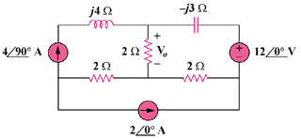

Figure 10.81
For Prob. 10.36.

